**Channel Drop Filters in the Design of Optical Logic Gates and Improving the Efficiency of Solar Cells**

Patrick Duke Anderson

*Southern Methodist University*

*The majority of optical waveguides operate under the principle of total internal reflection. However, light can also be guided under a rivaling principle, where wave propagation is forbidden in certain directions. As the push for optoelectronic devices has continued to increase, photonic band gap crystals have emerged as a potential champion in the field of integrated photonics. One photonic crystal configuration, the channel drop filter, has particularly attractive features since previous research has demonstrated 100 % optical transmission into the drop channel. In this paper, we revisit some of the theory surrounding the operation of a channel drop filters and allude to potential applications in the realm of photovoltaics and optical logic.*

**V**arious methods concerning the confinement and guiding of light have emerged within the field of integrated photonics**1**. Traditional waveguides (such as the planar slab waveguide and step-index circular waveguide) all operate under a similar principle; the guiding mechanism stems from light’s inherent attraction towards regions with a higher dielectric constant**1**. Total internal reflection is achieved in part by ensuring the guiding material maintains a higher refractive index than that which surrounds the waveguide**2**. Specifically, the critical condition for total internal reflection can be described as follows:

${ θc=sin}^{-1}{{(n2}/{n1)}}$*Equation 1*

Despite this largely understood mode of operation, light can also be guided by forbidding its propagation in certain directions**1**. Photonic crystals, which are idealized as lossless periodic dielectric mediums, can be constructed to introduce such “photonic band-gaps”**3**. However, one dimensional-photonic crystals (such as brag-reflectors or quarter wave-stacks) are not new to the scientific community**3**. In fact, Lord Rayleigh first described the phenomenon of total reflection from waves propagating through periodic mediums in 1887**4**.

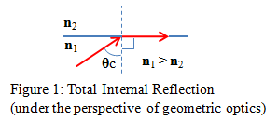The concept of photonic band gap crystals, however, is not limited to one dimension**3**. Eli Yablonovitch, one-hundred years after Rayleigh’s publication, introduced the idea of a three-dimensional periodic dielectric structure designed to suppress spontaneous emission in solid-state devices**5**. This design proved to be a crucial step in improving the efficiency of semiconductor lasers and solar cells**5**. In recent years, photonic crystals have continued to attract fervent interest in the scientific community due to their dispersion properties and ability to strongly localize light**6**. As a consequence of these characteristics, in addition to their compactness, photonic crystals have materialized as lead contenders for large-scale optical integration**6**.

As global communications have increased the use of optical fiber networks (thanks in large part to vast bandwidth of dielectric materials) interest has been incited in new methods of wavelength division multiplexing**7**. Although a score of WDM devices have been introduced, resonant cavities are particularly attractive candidates since they can select a channel with a slim linewidth (provided their quality factor is large)**8**. Such channel dropping filters are designed to access one channel of a WDM signal while leaving all other wavelengths unperturbed**8**.

Investigations have shown that ring resonators can be employed as highly efficient channel drop filters**9**. However, micro-ring resonators cannot exist as purely single mode devices and have radiation losses which tend to exponentially increase as ring of the radius decreases linearly**8**. As a result, photonic crystal, channel drop filters have been devised; in contrast to micro-ring resonators, photonic crystal resonators can be purely single-mode and do not suffer from radiation losses attributed to surface aberrations**8**.

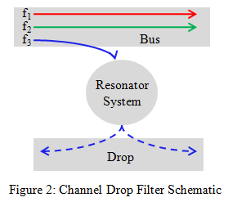Assuming that a photonic crystal structure is utilized, a single resonant state can be supported if specific requirements are met. Moreover, near 100% optical transfer from the bus to drop has been demonstrated through careful design of the bulk crystal and point defects**8**.

Figure 2 shows a channel drop filter configuration consisting of a single resonator. Assuming a propagating wave in the bus sufficiently excites a mode within the resonator, the resonant mode will eventually decay along both directions in the drop channel. Consequently, if a forward channel drop filter is desired, it is necessary to introduce a second resonator which is able to cancel the reflected signal through complete, destructive interference**8**. In order for the signals to destructively interfere along the backward direction, the resonators must support the same resonant frequency**2**. Previous research has lead to the design of such dual-resonant systems where degeneracy is purposefully introduced**8**.

The condition for cancellation can be illustrated by considering the propagating wave being guided within the bus. This plane wave ${ e}^{i(kx-wt)}$ can be decomposed into even and odd constituents**10**.

*Equation 2*

In the equation above *k* represents the magnitude of the k-vector, *x* is the distance along the waveguide, *w* is the angular frequency of the wave and *t* is time. The $\cos\left(kx-wt\right)$ portion is even with respect to the mirror plane symmetry (which runs orthogonal to the waveguides) and only couples to the even resonant state**8**. In a similar manner, $\sin\left(kx-wt\right)$ only couples to the odd resonant state**8**. Although the even state decays with the same phase along both directions of the channel, the odd state decaying along the back of the channel is 180○ out of phase with that of the odd state decaying in the forward direction**8**. By adjusting the dielectric constants of the rods surrounding the resonator (in addition to the characteristics of the point defect) total cancellation can occur in the backwards direction of the drop channel and forward direction of the bus**8**.

One design previously proposed for meeting the guidelines for total transmission in a forward channel drop filter consists of two single-mode cavities (as mentioned formerly)**8**. In this particular configuration, the two-dimensional bulk lattice is made of dielectric rods positioned in a square configuration**7**. These rods maintain a dielectric constant of 11.56 and a radius of 0.20*a* (where *a* refers to the lattice constant of the crystal)**7**. To ensure the quality factor of our two resonant states are made equal, the guided mode’s wave-vector must abide by the relation ***k·d =*** *n +* **8***.* In this equation *n* is any integer and ***d***is the separation between the two point defects**8***.* Separating the defects by five lattice constants will satisfy this condition so long as the dielectric constants of the four surrounding rods (shown in blue in Figure 3) are adjusted to ensure the guided mode maintains 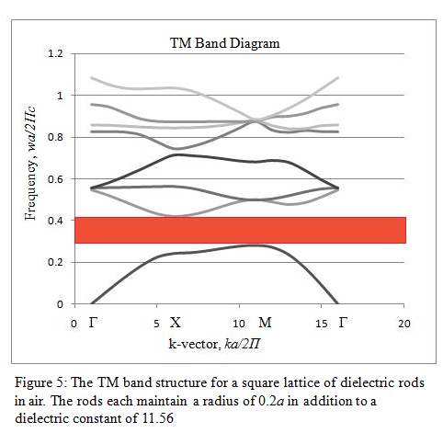a k-vector magnitude of 0.25a-1**8**.

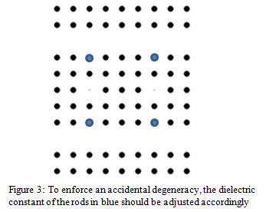

The bus and drop waveguides are introduced in the crystal by creating two line defects above and below the resonators which are separated orthogonally by 6*a***8**. Two resonators are formed from point defects in the photonic crystal by reducing the radius of two columns to 0.05*a* and decreasing the respective dielectric constants of the rods to 6.6**8**. Lastly, the aforementioned rods from Figure 3 are adjusted such that an accidental degeneracy occurs; this degeneracy is enforced by changing the dielectric constant of the four rods to 9.5**7**. Figure 4 shows the resulting geometric configuration.

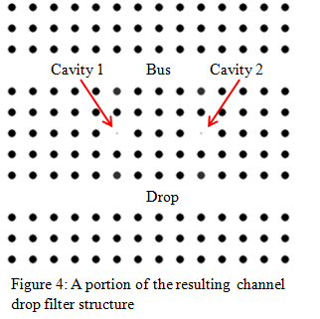The specific motivation for all of these constraints cannot be directly understood until a frequency analysis is completed. This type of analysis can be completed in MPB; in it, we seek to find the band gaps of just the bulk lattice before any defects are introduced. As shown in Figure 5, this particular structure has a TM polarized band gap for all frequencies *(wa/2 $π$ c)* between 0.283 – 0.419.

If we launch a transverse magnetic wave down this waveguide which has a frequency within the band gap elucidated in Figure 5, the wave should be entirely confined within the channels of the crystal. Moreover, we can carefully adjust the radii or dielectric constants of our point defects to ensure our cavities are designed for the correct resonance. Fortunately, the structure provided in Figure 4 has already compensated for this resonance parameter**7**. The normalized resonant frequency of each resonant cavity is shown in Figure 6. Please note that although previous publications have boasted 100% transmission with this configuration, I was only able to obtain 30.3 %.

This channel drop configuration can be extended to accommodate the transfer of multiple frequencies. The incorporation of various channel drop filters can broaden the frequencies range which might be transferred into the drop. The point defects which define the core of these resonator pairs can be adjusted to tune for various frequencies. This resonant tuning can be accomplished by changing the radius of the defects, or alternatively, by adjusting their dielectric constants appropriately. A succession of channel drop filters might be particularly desirable in something such as a photovoltaic application. 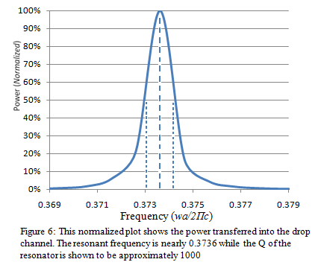

Currently, the power loss associated with short-wavelength in silicon solar cells is on the order of 32%**11**. However, this wavelength-band mismatch could be addressed by redirecting the high-frequency components to an alternative material which possesses a band-gap compatible with the energy of the light**11**. We can select the appropriate material band-gap since we know the energy carried by light to be *E = hv***2**.

Figure 7 shows a configuration capable of separating two different frequencies. The first channel drop filter is tuned to a resonant frequency of 0.3736, while the second is designed for 0.32591. The point defects of the second filter maintain a radius of 0.15*a* and a dielectric constant of 6.6. Interestingly enough, both signals were transmitted to the drop with approximate 30% efficiency.

Given the scale-invariance of Maxwell’s Equations**3**, these two *unit-less* frequencies could be adjusted to match wavelengths in the near ultra-violet spectrum. For instance, if we desired the normalized frequency of 0.3736 to associate with a wavelength of 450 nm, we only need to adjust the length of our lattice constant. In this case, a lattice constant of approximately 168 nm suffices.

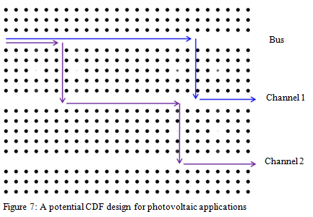

Another potential application for channel drop filters resides within the nascent field of optical logic. Particularly, if basic NAND or NOR gates could be created with the help of photonic band-gap crystals, optical latches could feasibly be manufactured**12**. In turn, such optical latches could contribute directly to the creation of optical flip-flops and the inception of optical sequential logic circuits**12**. XOR optical gates are primarily appealing since they can be demonstrated with channel drop filters relatively easily. The truth table and graphical symbol for an exclusive-OR gate are included in Figure 8.

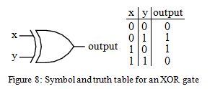 Figure 9 depicts a preliminary XOR design involving two separate channel drop filters. It should be noted that these channel drop filters are each designed for the normalized frequency of 0.3736. Thus, this is the frequency which excites each channel whenever an input is designated to be *on.*

The first case in the XOR truth table is trivially true since signals would be absent from each channel; obviously, nothing will be transmitted optically to the output channel in this situation. The fourth scenario can also be easily obtained if the channel drop filters are designed identically. Since our channel drop filters only transmit in the ‘forward’ direction of the ‘drop’, we can exploit symmetry as well. (Please note that ‘forward’ and ‘drop’ are *relative* terms in this context). Complete destructive interference occurs when the filters are separated by a distance that ensures the signals are 180 ○ out of phase when they meet in the output channel.

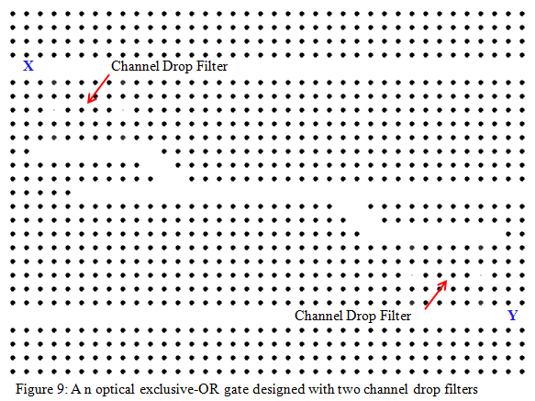

The remaining two cases are ultimately what demand the structure depicted in Figure 9. If we had instead *directly* coupled our filers to the output channel, then the concept of *reciprocity* tells us our signal would eventually be coupled into the alternative input channel**1**. Our current geometry, to a large extent, avoids this reciprocity. However, the existing geometry does lead to losses attributed to the small channel openings, as shown in part (a) of Figure 10. For instance, if only input *x* is *on*, then this signal is eventually coupled into the output channel. However, before it reaches the end of the output channel, some of the signal will be split into the cavity beneath input *y.* As a consequence of this coupling, the existing model should be viewed as incomplete. Regardless, it is successful in illustrating the viability of channel drop filters in future optical logic design.

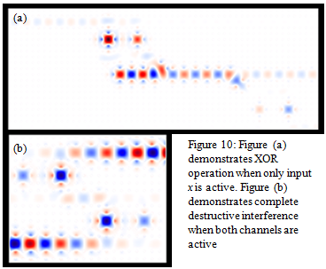

**References**

**1**Pollock, C. R., and Michal Lipson. *Integrated Photonics* . Boston: Kluwer Academic , 2003. Print.

**2**Saleh, Bahaa E. A., and Malvin Carl Teich. *Fundamentals of Photonics* . New York: Wiley, 1991. Print.

**3**Joannopoulos, J. D.. *Photonic Crystals: Molding the Flow of Light*. 2nd ed. Princeton: Princeton University Press, 2008. Print.

**4**Rayleigh, Lord. "On the Maintenance of Vibrations by Forces of Double Frequency, and on the Propogation of Waves through a Medium endowed with a Periodic Structure." *Philosophical*

*Magazine and Journal of Science* 24.147 (1887): 145 - 159. Print.

**5**Yablonovitch, Eli. "Inhibited Spontaneous Emission in Solid-State Physics and Electronics." *Physical Review Letters* 58.20 (1987): 2059 - 2062. Print.

**6**Wu, Yaw-Dong, Ke-Wei Hsu, Tien-Tsorng Shih, and Jian-Jang Lee. "New Design of Four-Channel Add-Drop Filters Based on Double-Resonant Cavity Photonic Crystals." *Journal of the Optical Society of America B* 26.4 (2009): 640 - 644. Print.

**7**Fan, Shanhui, Pierre R. Villeneuve, J. D. Joannopoulos, M. J. Khan, C. Manolatou, and H. A. Haus. "Theoretical Analysis of Chanel Drop Tunneling Processes." *Physical Review B* 59.24 (1999): 882 - 892. Print.

**8**Fan, Shanhui, Pierre R. Villeneuve, and J. D. Joannopoulos. "Channel Drop Filters in Photonic Crystals." *Optics Express* 3.1 (1998): 4 - 11. Print.

**9**Little, B. E., S. T. Chu, H. A. Haus, J. Foresi, and J. P. Laine. "Microring Resonator Channel Dropping Filters." *Journal of Lightwave Technology* 15 (1997): 998. Print.

**10**Brown, James. "I dunno Chapter." *Complex Variables and Applications, 8th Edition*. dunno. Reprint. I dunno: McGraw-Hill College, 2008. I dunno Page. Print.

**11**Florescu, Marian, Hwang Lee, Irina Puscasu, Martin Pralle, Lucia Florescu, David Z. Ting, and Jonathan P. Dowling. "Improving Solar Cell Efficiency Using Photonic Band-Gap Materials." *Solar Energy Materials and Solar Cells* 91 (2007): 1599 - 1610. Print.

**12**Mano, M. Morris. *Digital Design, 3rd Edition*. 1984. Reprint. Englewood cliffs, N.J.: Prentice-Hall, 2002. Print.